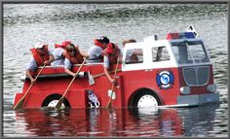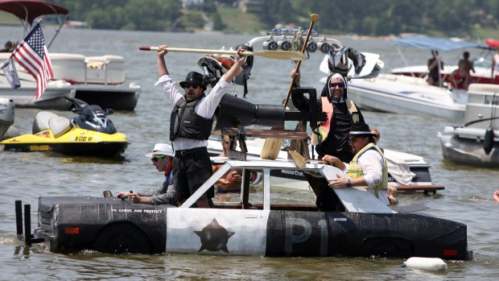
GATHER YOUR TIKI VILLAGE AND GET IN THE RACE!

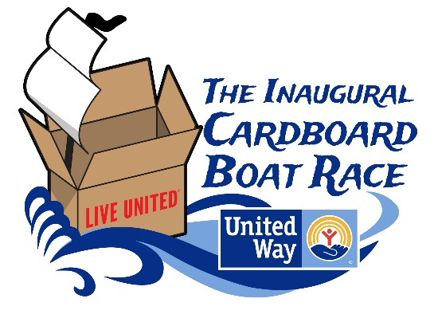

United Way of Bartow County
2021 CAMPAIGN KICKOFF

Sat. August 28, 2021 Pine Acres Retreat

3963 Bartow Carver Road, Acworth, GA
Fostering a positive company culture is tough. Designing, building and racing a boat together works wonders. Even better, you’re rallying behind United Way to launch our Community Campaign.
YOUR $500 ENTRY FEE GETS:
- 5 4’x8’ pieces of cardboard
- 2 Official T-shirts
- The ‘How to Build a Cardboard Boat’ Manual

RACE CALENDAR:
8/12/21 Registration
Deadline 8/27/21 Boat Drop Off &
Safety Briefing
8/28/21 Race Day
For the first time, companies across Bartow County have answered the call of the open sea. With little or no experience, they have built lake worthy crafts. Some crews will win. Some crews will sink. All will have a good time!
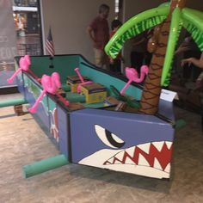
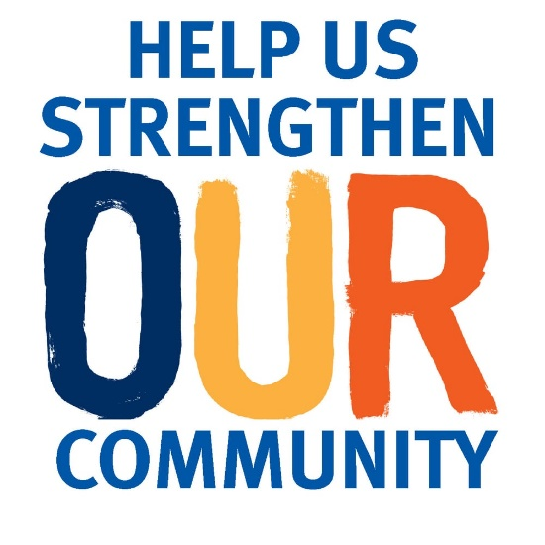

We need your help to launch our campaign with style. We have big plans ahead to help Early Childhood Education and Racial Equity in Bartow County. Help us show the difference our community can make when we come together.
Have fun. Get wet.
Make a difference.

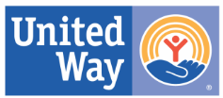
Contact United Way of Bartow County at 770.386.1677 or bartowliveunited.org for more information.

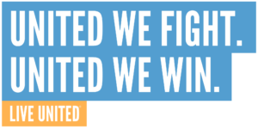
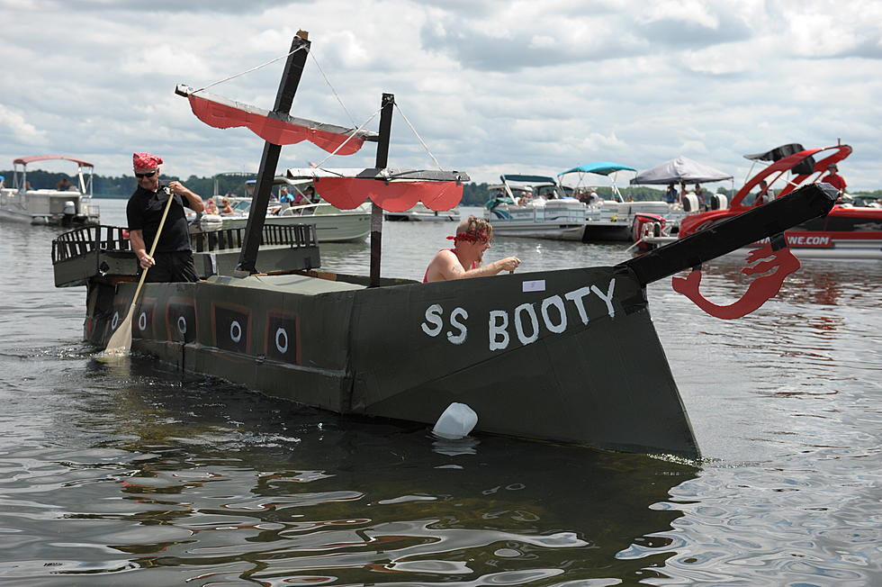

The Inaugural Cardboard Boat Race is the official kickoff event for United Way of Bartow County’s annual fundraising efforts. The event is meant to raise awareness, get people excited, celebrate the
spirit of working together and help increase workplace campaigns so that we can
better advance the common good.

Constructing a cardboard boat is also a great Team Building activity for your business. Planning, naming, building, and sailing your boat as well as attending the race has many workplace benefits:
- Facilitates better communication
- Promotes creativity
- Deepens relationships
- Increases morale
- Improves problem-solving skills
- Celebrates giving

Boats made entirely of cardboard and powered by two (or more) paddlers race around the cove at Pine Acres Retreat. Teams compete in heats for bragging rights, glory, and some pretty awesome trophies.

We have games for children and adults, food trucks, a beer garden, giveaways, and a festival like atmosphere with tents, a DJ, and over 1,000 people in attendance.

Build a boat (or multiple!), use your Tiki Bucks for lunch at our Food Truck extravaganza, bring a crew to cheer your team on to victory, and help support United Way in our fight to improve the lives of Early Childhood Education in our community!

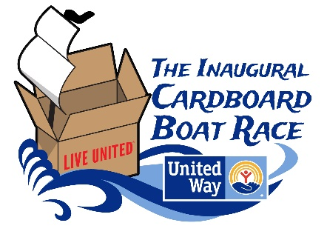

Questions? Contact us at 770.386.1677 or www.bartowliveunited.org

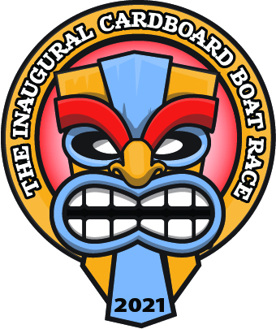

2021 Inaugural CARDBOARD
BOAT RACE REGISTRATION

Please use a separate Registration Form for each boat entry.
All lines must be completed.

Business Name
Business Address
Contact Name
Phone Number
Email
Captain’s Name
Captain’s T-shirt Size
First Mate’s Name
First Mate’s T-shirt Size
Name of Boat

Boat Registration | Amount | # | Total
Boat Entry Fee | $500
Additional T-shirts* | $10/each
TOTAL

Additional Shirts | S | M | L | XL | XXL | XXXL | Total
Number

*Two t-shirts included with Registration Fee

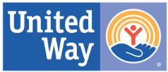
Please make checks payable to: United Way of Bartow County PO Box 1264, Cartersville,GA 30120

Contact us at 770.386.1677 or morehouse.brenda@gmail.com

Come float your boat
2021 SPONSORSHIP OPPORTUNITIES

COMMODORE

$10,000 Commodore Level
- Primary parking spot at Pine Acres Retreat
- One Boat registration & $250 in Tiki Bucks
- Primary spot on all signage, media, advertisement
- Premier cove spot

ADMIRAL
$5,000 Admiral Level
- Primary parking spot at Pine Acres Retreat
- One boat registration & $125 in Tiki Bucks
- Secondary spot on all signage, media, & materials
- Secondary spot in paid media ad
- Secondary Cove spot

$2,500 Captain Level
CAPTAIN
- Recognition on signage, media, & materials
- One boat registration & $75 Tiki Bucks
- Tertiary Cove spot

$1,000 First Mate Level
FIRST MATE
- Recognition on Race Day signage
- $25 Tiki Bucks
- Preferred cove spot

- 2 t-shirts
NAVIGATOR
$500 Navigator Level
- Recognition on Race Day signage
SAILOR

Company: Contact: Signature:

Date: Phone: Email:

In-Kind Sponsor
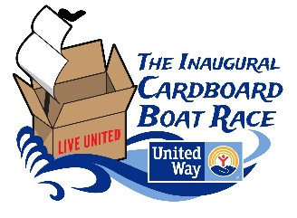
- Recognition in area of donated products

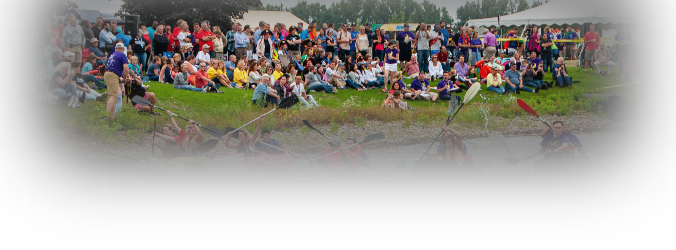
Enclosed check (made out to United Way of Bartow County) Bill me

PEOPLE’S CHOICE AWARDS

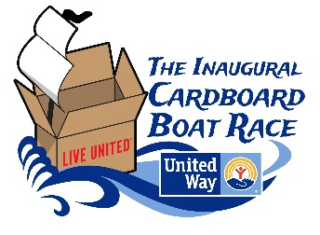
HELP UNITED WAY IMPROVE LIVES IN
OUR COMMUNITY!

We’re excited you’re taking part in United Way’s 2021 Inaugural Cardboard Boat Race!
Together we are going to have a boat load of fun, and in the process, we will be fighting side by side for the health, education, and financial stability of every member of our community.
On Race Day we’ll have food trucks, games, tents, a DJ, and a festival-like atmosphere. Most of the fundraising, however, is done before the boats hit the water. Our main revenue sources are sponsorships and fundraising by boat teams competing to win the two coveted People’s Choice Awards (this is where you
come in!).

There are two distinct People’s Choice Awards:
Largest Tiki Hut Award - presented to the company that raises the most money
Most Tiki Totems award- presented to the company that has the largest number of individual donors

Funds are raised in advance of and on race day. Donations can be made either electronically, by check or in cash on race day. Your funds will be tracked via an online crowdfunding page (more on that in a moment).

That’s great! How do I raise bountiful tiki bucks?
We encourage you to have fun and get creative in your fundraising efforts!
For starters, here are two sure ways to bring in the loot:
  - Put together a raffle a prize and have your supporters buy tickets online. All funds raised will go towards your sponsorship to United Way of Bartow County.
  - Create a fundraising page under the race platform to promote your grand TIKI BOAT. Ask supporters to donate to your cause and vote for your TIKI BOAT.
  - Have a fundraiser at your place of work or in your community. Donate the proceeds to your sponsorship to United Way.
In the spirit of LIVING UNITED:

“We work with some really good people who are extremely supportive of our Bartow County Community and the local businesses, so when you ask them to support an organization that is important to you, they step up with some very generous donations. We know, with just a little work and a lot of fun, you will be thrilled at the positive impact and will strive to make this year is a great success for United Way and the Bartow County Community – President Brenda Morehouse

(Continued on back)

PEOPLE’S CHOICE AWARDS

HELP UNITED WAY IMPROVE LIVES
IN OUR COMMUNITY!

By asking vendors to sponsor their boats, they were able to raise exponentially more than in previous years and bring in dollars from as far away as China to put to work for families in their local county. We can do this right here in Bartow County with YOUR support!!

They asked their vendors to sponsor their boats in one of two ways:
- Sponsor their boats through a direct donation made out to United Way of Bartow County.
- Sponsor their boats by discounting their invoices so that they could pass the discounted amount to United Way. (For example; Vendor X sent a $20,000 invoice to LaSalle Bristol. Vendor X agreed to decrease their invoice to $19,000 so that $1,000 could be given to United Way.)
To learn more about this creative approach to fundraising, see the attached Word document. Feel free to modify it with your own company name and logo and use it to solicit boat sponsorships.

This year we also have an exciting all-hands-on-deck crowdfunding approach:
Your MobileCause fundraising page will allow you to collect donations online and via text message. This page will also keep track of the funds you’ve raised and allow you to see how other teams are doing.

In addition to cheering you on at the race on August 28th, your friends, family, and coworkers can help you win a People’s Choice Award and support United Way by donating to your crowdfunding page. Even if you don’t raise the most money, you can win the Most Totems Award by collecting many smaller donations.

We will set up a “Team” page for you and email you a link to your fundraising page.

You can find your profile here: TBA (click the Teams tab!). Your profile will show your team’s unique text message code that you can use to help secure donations (Text FLOAT# to____). (set up after registration)

You can now begin fundraising for your team! Click the social media icons to easily share to your page via Facebook, Twitter, and email. To compare your progress to other teams’ fundraising efforts click this link or text FLOAT to ___“TBA” and click the “Teams” tab. Be sure to use the form below to engage more support!

Happy fundraising, and may you raise bountiful Tiki Tokens to bolster lives in our community!

Checks can be mailed to Questions? Contact Brenda Morehouse
United Way of Bartow County 770.386.1677
PO Box 1264 morehouse.brenda@gmail.com
Cartersville, Ga 30120

ANY PERSON WHO WILL BE IN THE WATER (even to just get your feet wet!) MUST HAVE ONE OF THESE FILLED OUT. Make additional copies for your entire crew.

2021 United Way of Bartow County The Inaugural Cardboard Boat Race
PARTICIPANT WAIVER/HOLD HARMLESS AGREEMENT

I, the undersigned, wish to participate in the 2021 United Way of Bartow County “The Inaugural Cardboard Boat Race,” on Saturday August 28, 2021

I understand that the activities involved with the race contain an element of hazard or risk. I recognize the inherent danger involved and take full responsibility for my actions and physical condition.

In consideration of my participating in the race, I hereby, for myself, my heirs, executors and administrators, waive and release any and all rights and claims for damages I may have against the United Way of Bartow County and its employees, agents, representatives and successors and any other group or individual associated with this event for any personal injuries or property damage or loss suffered while engaged in the race activities.

I agree to indemnify and hold the United Way of Bartow County and any other group or individuals associated with the event and any of their servants, agents, officials or employees free and harmless from any liability, loss, cost or expense including attorney fees, which may result from my participation in the race activities. I agree that I am fully responsible for payment of all costs resulting from the rendering of medical aid and ambulance services to me as a participant in any race activities and I authorize that all necessary first aid steps may be taken as prescribed by qualified personnel. I also grant full permission to use any photographs, videotapes, recording or any other record of my participating in the race program for any purpose. By signing below, I agree that I understand and consent to this statement.

I hereby grant the United Way of Bartow County permission to use my likeness in a photograph/video in any and all of its publications, including website entries, without payment or any other consideration. I understand and agree that these materials will become the property of the United Way and will not be returned.

I hereby irrevocably authorize the United Way to edit, alter, copy, exhibit, publish or distribute this photo/video for purposes of publicizing the United Way’s programs or for any other lawful purpose. In addition, I waive the right to inspect or approve the finished product, including written or electronic copy, wherein my likeness appears. Additionally, I waive any right to royalties or other compensation arising or related to the use of the photograph/video.

_________________________________________________________________________
Print Name of Participant Date

__________________________________________________________________________
Company

_________________________________________________________________________
Address City Zip Phone

__________________________________________________________________________
Signature of Participant Date of Birth

___________________________________________________________________________
Contact in Case of Emergency Phone Number

The Inaugural Cardboard Boat Race!

is partnering with United Way of Bartow County to improve lives in our community through supporting The Inaugural Cardboard Boat Race, the kick-off fundraiser for the annual United Way campaign. Over the years, many have dreamed the call to the open water - some crews will win, and some will go under, but everyone will have a great time!
The United Way needs your help to launch a campaign with style. There are big plans ahead for working families in Bartow County. Please help _ support United Way by sponsoring our boat in this year’s race. The event will take place on August 28th at Pine Acres Retreat. Hundreds of people from businesses across the county will gather for this fun event that will become a local tradition, and this year is the year to set the mark!
We are reaching out to our suppliers to ask for your support by sponsoring our boat. is committed to building a boat. We will adorn our cardboard boat with the company logos of those who participate in the sponsorship. Additionally, we will add your company name and logo to a sign next to the boat. This a great opportunity to contribute to an awesome organization and get a little extra PR. We would also encourage each of you to join in on the festivities on the 28th. Thanks in advance for your generosity!

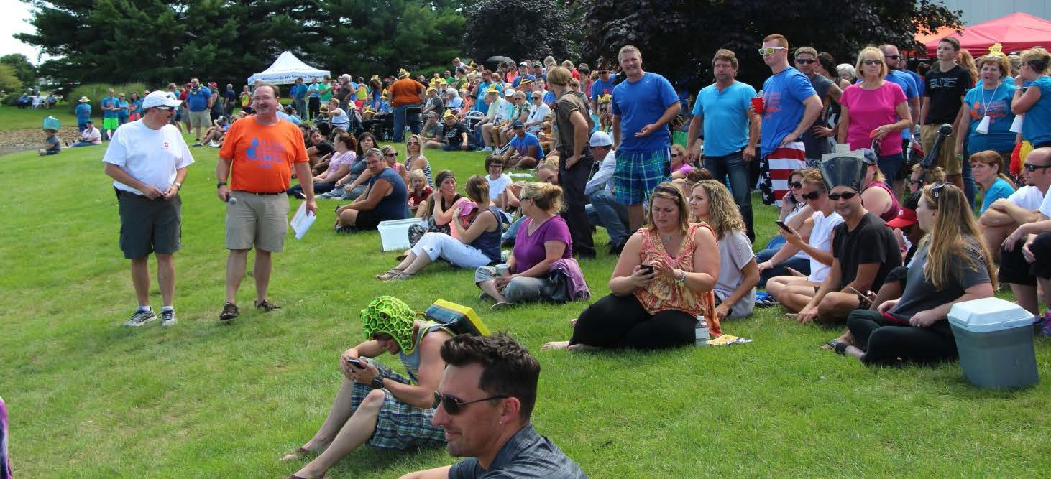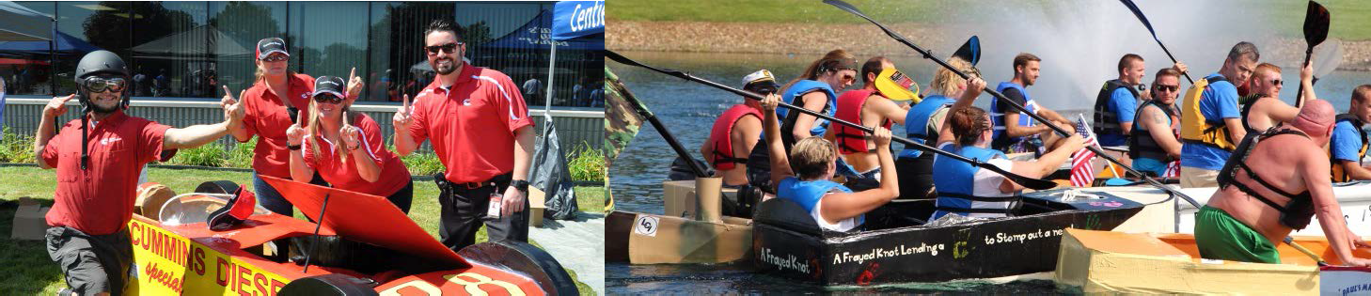

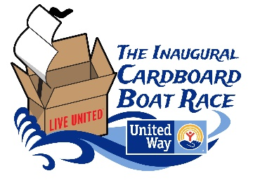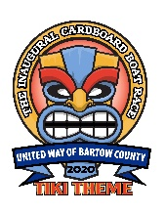

Company Logo

YES, I want to sponsor your boat!

Please fill out this form and send it along with your check or invoice reduction amount to:

Company Name Address Address Line 2
ATTN: Employee Name

Contact Name
Business Name
Business Address
Phone Number
Email

Sponsorship Amount:
$500 $1000 $1500 $2000 Other:

Please make checks payable to United Way of Bartow County

OR Reduce My Invoice By:
$500 $1000 $1500 $2000 Other:

The amount of your invoice reduction will be donated to United Way of Bartow County

Thank you for your donation!

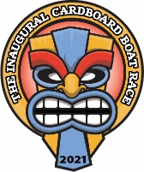

Company Logo

